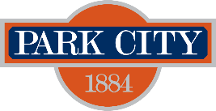
Nonprofit Services Advisory Committee 2026 – Regular Meeting Schedule
In accordance with Utah Code § 52-4-202, the Park City Nonprofit Services Advisory Committee hereby provides public notice of its regular meeting schedule for the 2026 calendar year.
Meeting Details:
- Time: Wednesdays from 6:00 PM to 8:00 PM (unless otherwise noted)
- Location: 445 Marsac Avenue, Park City, Utah
- Virtual Access: Meetings will also be accessible online, with options to listen, watch, or participate virtually. For details on how to attend virtually, please visit www.parkcity.gov.
Scheduled Meeting Dates:
- January 14, 2026
- April 8, 2026
- July 15, 2026
- October 14, 2026

